

|  |  |
| --- | --- |
| **Name** | **Komal Fawad**  **Maham Iftikhar** |
| **Subject** | **OOPS** |
| **Theory Assignment#4** | **Snake game** |
| **Roll no.** | **SP24-BSE-053(B)**  **SP24-BSE-056(B)** |

**SUBMITTED TO:**

**Sir Muhammad Shahid Bhatti**

|  |
| --- |
| Snake and ladder game |

# Login screen:

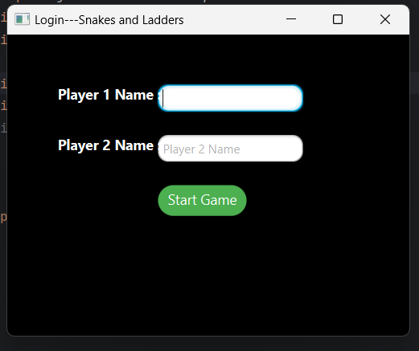

# Warning label:

It appears if both the text fields are empty

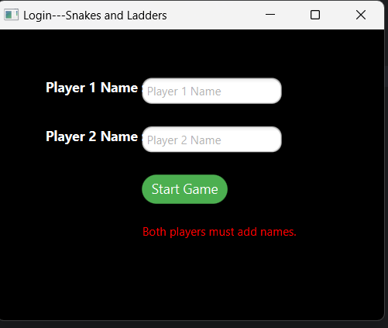

# Game window:

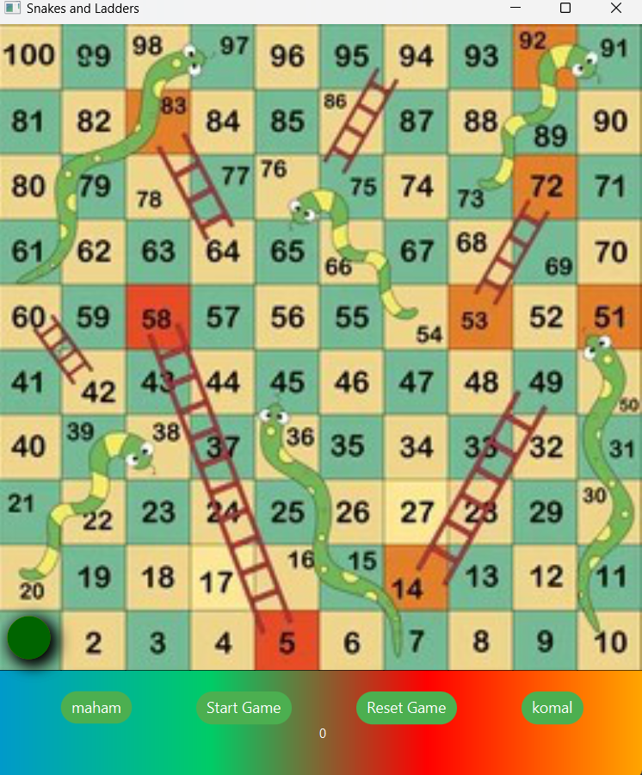

# Buttons:

* Maham and komal here represents the player buttons which are used to decide turns
* Start button initiates the game and set the turn of both players to true and plays the audio in background
* Reset buttons sets the players to initial positions again



# Players:

Players are indicated by circles



# Dice values:

Dice values are generated by random function.



# Ladder:

It moves the players in ascending order

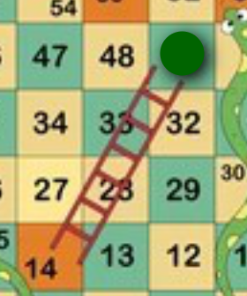

# Snake:

Moves the players in descending order

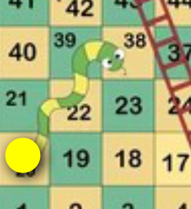

# Winner:

When a players reaches to 100 he/she wins and a winning label is displayed

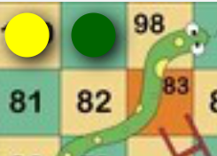

# File handling:

All the players name are saved to a text file

